3a:
----------------------------------------------------------------------
cProfile on matmult.py:
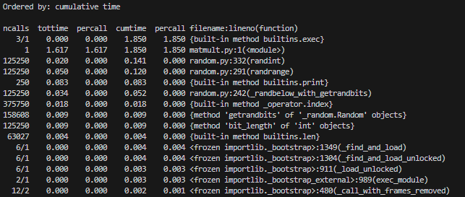
The cProfiler just tells me that the script itself takes the longest.
The obvious place to start optimizing is at line 22 where the nested for-loop (!!) starts.
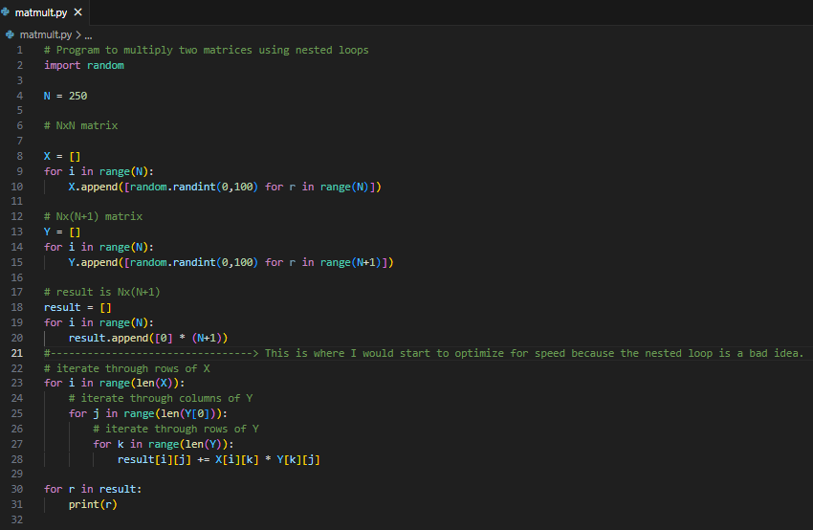

3b:
Running the Euler script went pretty fast and resulted in:
Running line_profiler resulted in: (really like this one!! Will use.) (phi never gets called??)
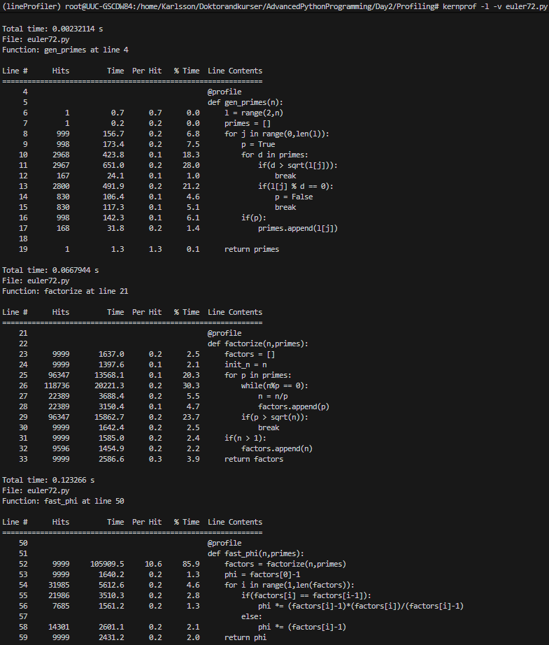

gen_primes runs for 1.2% of the total time.
factorize runs for 34% of the total time.
fast_phi runs for 65% of the total time.

I would hence start optimizing at line 64, just before the for loop with fast_phi.

3c:
Using time in bash we get for the “unoptimized” matmult.py:
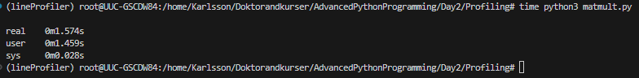

Using a nifty chatgpt-generated optimized nested-for-loop-alternative:
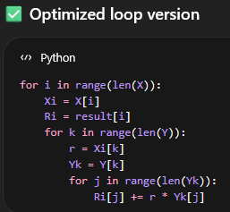
we get:
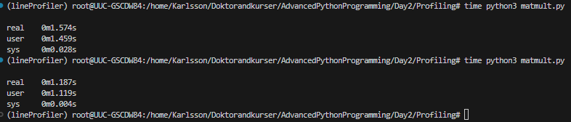

An incredible time save of 0.387s, or a whopping 25% time decrease!!

